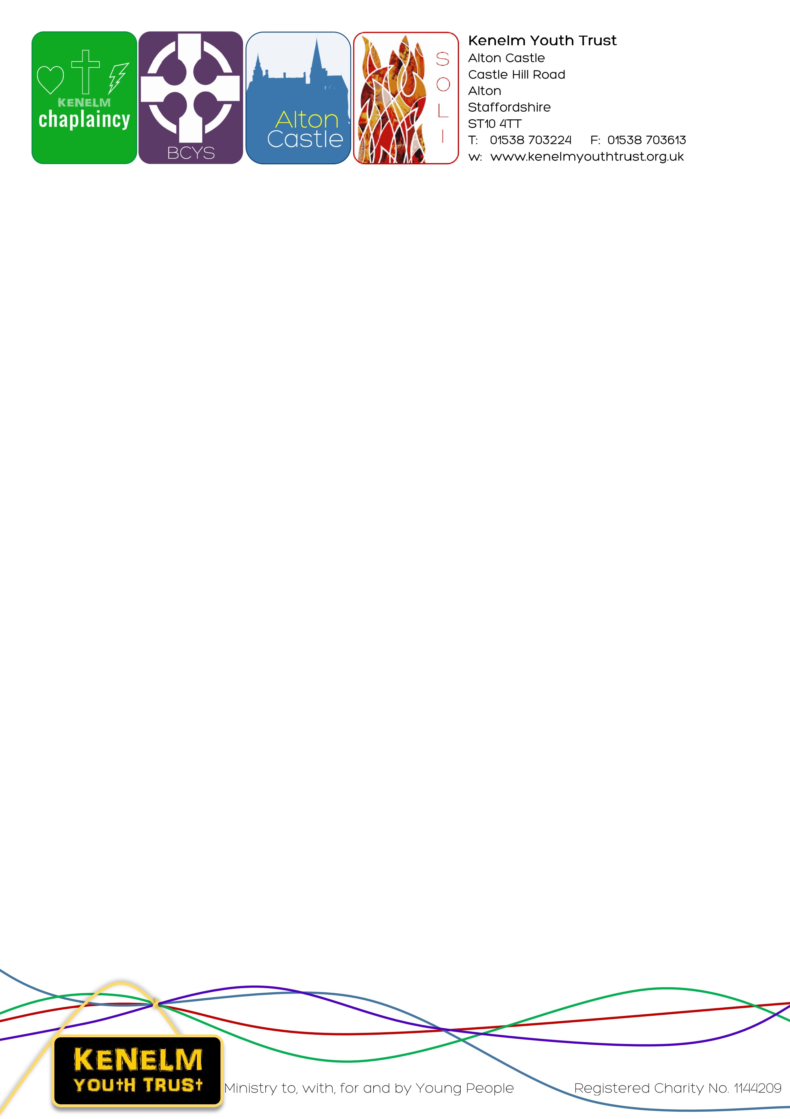

Dear Father,

The Solemnity of Christ the King is fast approaching once again. This is also the celebration of World Youth Sunday.

This summer over 80 young people joined the diocesan pilgrimage to World Youth Day, Lisbon lead by Kenelm Youth Trust. There were over 1.5 million people from around the world gathered with Pope Francis and really allowed our pilgrims to grow in faith and to truly experience the Universal Church.

Throughout the last academic year we were able to work with over 11,000 young people through our retreats at Soli Centre for Youth Ministry, Alton Castle and outreach in schools. At the time of writing this letter we have already worked with 3000 young people since September. Most of these young people have visited from schools within our Archdiocese.

As with all parishes and charities the financial burdens of increased costs has impacted us significantly. As we aim to fulfil the mission of the trust we are mindful that our charges do not make it prohibitive for young people to come on retreat to our centres. With this in mind, we once again ask you to promote and support the 2nd collection on the weekend of 25/26 November which is for Kenelm Youth Trust. The generosity of your parishioners really does have an impact on the faith formation of young people within our Archdiocese. It often helps parishioners to understand our work and its impact through a young person briefly speaking at the end of Masses. If you are willing for this to happen in your parish please contact Maria Bracken - [maria.bracken@kenelmyouthtrust.org.uk](mailto:maria.bracken@kenelmyouthtrust.org.uk) and she will be in contact with you.

The other significant fundraiser we have is the Kenelm Youth Trust Charity Ball which is taking place on Saturday 11th November at The Belfry, Sutton Coldfield. Tickets are available for this via our website

https://www.kenelmyouthtrust.org.uk/shop.html Please do book a ticket if you are able to join us and also encourage any parishioners who may be interested too.

We also have an exciting opportunity for young adults to join us on a mission trip to Malawi in July 2024. We are working in collaboration with St Francis Malawi Trust which was founded in Coventry. The trip will assist with work in a school and medical centre. The St Francis Malawi Trust seeks to assist communities in becoming self sustainable. If you know of any young adult in your parish who would be interested in this mission please invite them to read the information on our website and submit an application form. Applications must be received by 20th November.

Be assured of our prayers for you and your parish and please pray for us and the work of Kenelm Youth Trust.

Many thanks for your continued support,

Chris

Fr Chris Yule

Spiritual Director of Kenelm Youth Trust