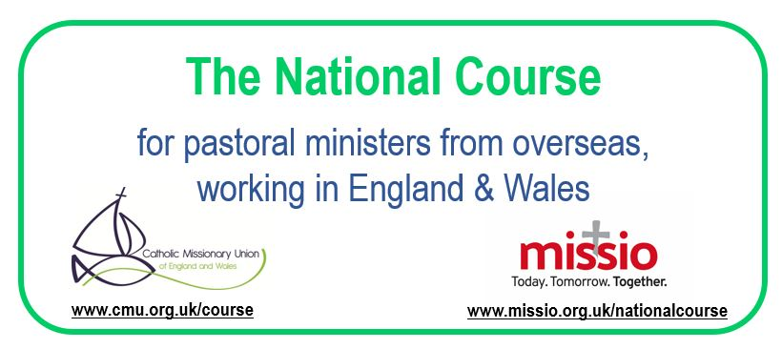

Course Description
The National Course is a collaborative project between Missio and the Catholic Missionary Union (CMU), begun in 2018, for pastoral ministers from overseas, working in England and Wales.
It is designed to help overseas Diocesan Priests and Religious Priests, Brothers and Sisters who have entered the UK:
- To value their own cultures as well as to be open to the culture in which they are serving,
- To be willing to share their unique personal gifts in the service of the Church here,
- To be able to cope with the complexity of ministry in a cross-cultural setting,
- To be available to others so that they can be approached with trust and confidence, without fear of being judged,
- To understand the vital need for Safeguarding structures to protect children and vulnerable adults and to follow the current guidelines strictly,
- To be friends, in the host culture, to those whom God loves in a special way: the outcast, the stranger, the poor and the sinner,
- To possess a profound respect for other people, cultures, and religions, discerning the presence of God in their midst and willing to listen to and learn from them, and adapt accordingly,
- To reflect on how they can support the Church here to grow in its appreciation of diversity and include other cultures and traditions,
- To communicate something of the freshness and vitality of the Church from which they come,
- To value collaboration with priests, deacons, and pastoral agents in the Local Church, and
- To equip them with the means to become effective and fulfilled servants of the Local Church.

Dates and Fees
Participants must attend TWO workshops as follows:
- Part 1 – Monday 9th to Friday 13th September 2024
- Part 2 – Monday 5th to Friday 9th May 2025

Both workshops will be held at the Oblate Retreat Centre, Wistaston Hall, 89 Broughton Lane, Crewe, CW2 8JS
The cost of the course is £1,100 per person, all-inclusive apart from transport costs, payable by 1st August 2024.
For further information, please contact Fr Anthony Chantry at director@missio.org.uk

