Ethnic Chaplaincies

Newsletter 23 February 2025

Dear All,

I am pleased to send you my weekly Reflection for the 7th Week of the Year: I have drawn on the celebration of the Coptic Martyrs, an inspirational story that we have now incorporated into the Roman Martyrology. The Coptic Cathedral is nearby in Solihull, and I am thinking of arranging a visit there for the Jubilee Year. Please let me know if you are interested.

I am also forwarding:

* information on cancer screening that could be helpful to your Chaplaincy/Church Community. This has come from Paula Mitchell, the Social Welfare Adviser in the Archdiocese.
* A leaflet on Sacred Heart Devotion from Paul Northam, the Diocesan Adviser for Evangelisation, and Co-ordinator of the Jubilee Year. It is the 350th Anniversary of the Apparitions of the Sacred Heart to St Margaret Mary and you may wish to renew the Devotion among your people.
* And finally “The Story of Knock” a lovely video about the Apparitions and development of the International Shrine of Our Lady in the West of Ireland: For those on Facebook <https://www.facebook.com/share/16FC3S4VLb/?mibextid=wwXIfr> or directly available on the Knock Shrine website at: <https://www.knockshrine.ie>
* I am happy to send you an invitation from the Ukrainian Community to the 3rd Anniversary Event of Russia’s invasion at Coventry Cathedral. I am sure they would appreciate your support.

I am sending this Newsletter in a Word document so that it can be printed for Chaplaincy/Church members.

We are all praying for the Holy Father at this time herewith a reminder of the Icon he prays before in St Mary Major Basilica.

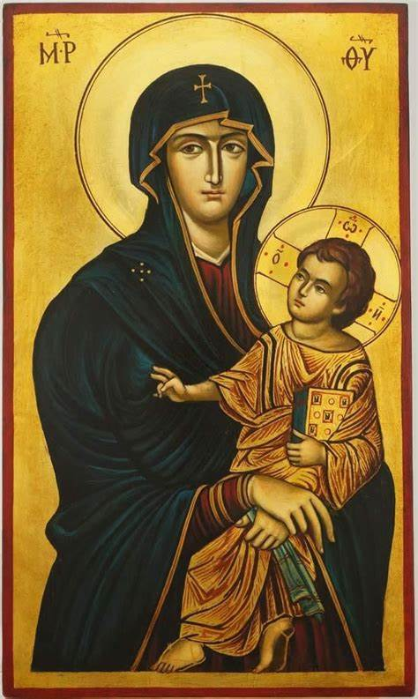

My thoughts and prayers are with you in your important pastoral work.

God Bless

Mgr Daniel McHugh

**The Ethnic Chaplaincy is part of the Archdiocese of Birmingham**

**Registered Charity No. 234216**

**Co-ordinator: Mgr Daniel McHugh**

**Email:** [co-ordinator.ethnic.chaplaincy@rcaob.org.uk](mailto:co-ordinator.ethnic.chaplaincy@rcaob.org.uk)

**Website:** <https://ourladyofgoodcounsel.org.uk>

You will find our vlog “Burning Bush” and a weekly newsletter on the website

**The Ethnic Chaplaincies are expected to follow the Safeguarding Guidelines of the Archdiocese**

**The Archdiocesan Safeguarding Team can be contacted on:** 0121 230 6240

**Safeguarding** **Hong Kong Community:** Shirley Wong, Email: [sg.ethnic.chaplain.hk@rcaob.org.uk](mailto:sg.ethnic.chaplain.hk@rcaob.org.uk)